Internal marks entry new page user manual.

1.Click on edit button first to enter marks.

2. Displayed following screen select radio button (Mark Entry in Excel).
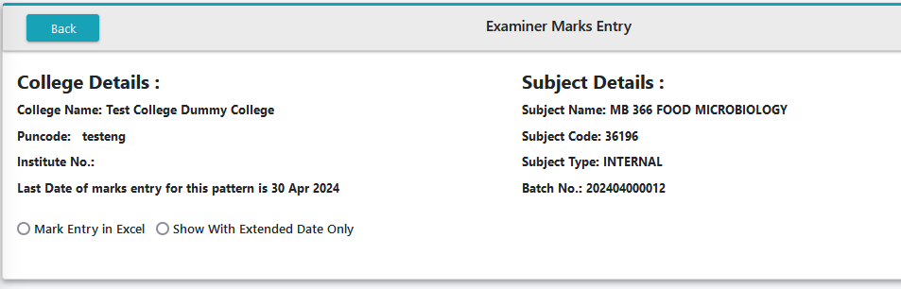
3. After that displayed screen click on Show button.
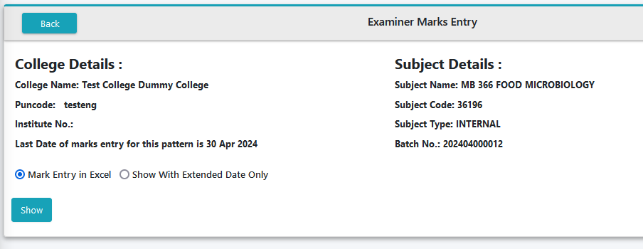
4. Click on Download Excel.
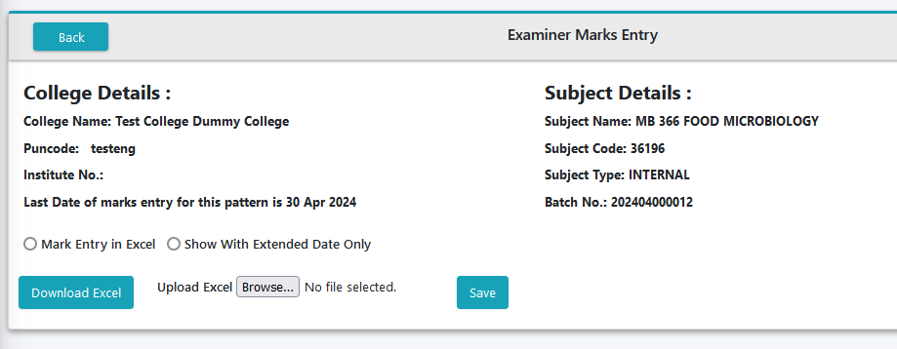

5. Downloaded excel displayed like that. Don’t change any other column besides MarksObtained.
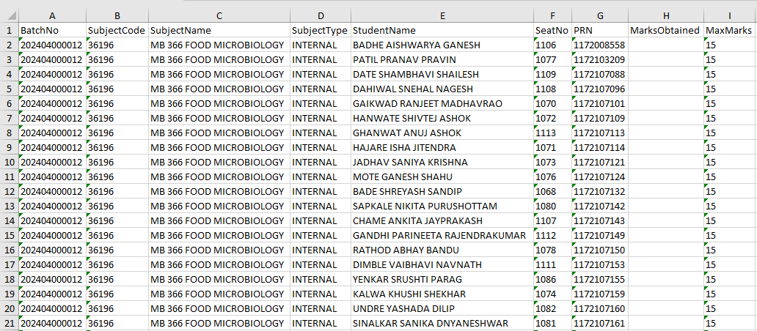

6. You can enter student’s marks and AB for Absent, NA for Not Applicable IF Grade subject then you can enter grade also here.
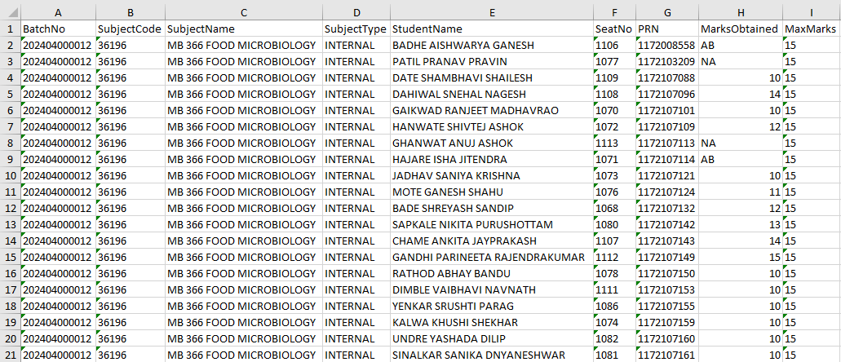
7.After That click on Browse button and Browse the file where do you have save and click on Save button.
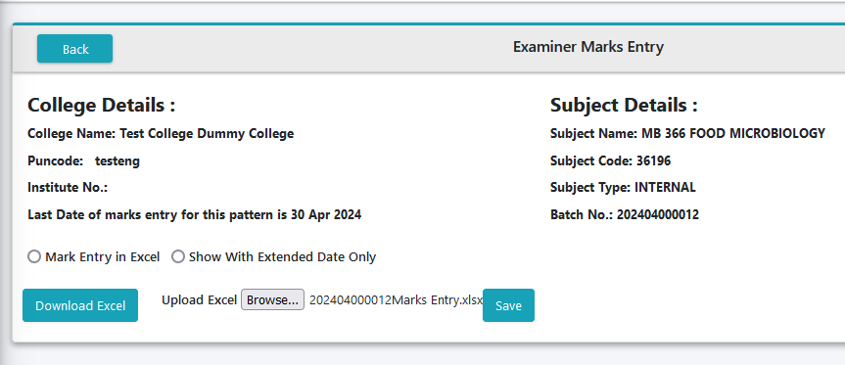

8.After click on save shown following Message Excel Upload Successfully.(click on close button)
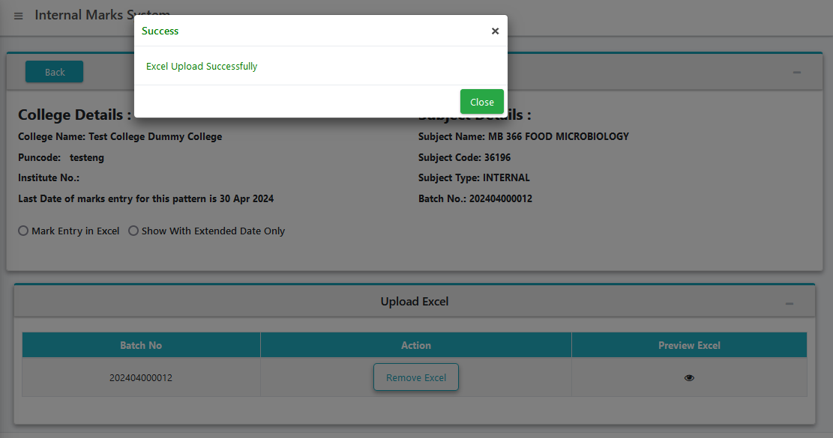
9. displayed following details to remove excel or show preview.
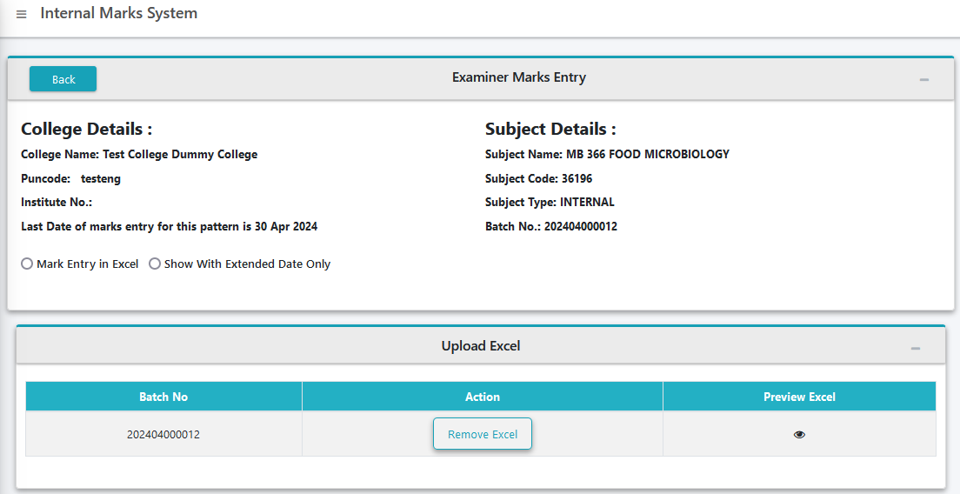
10. Click on Eye logo you can show preview as like follow.
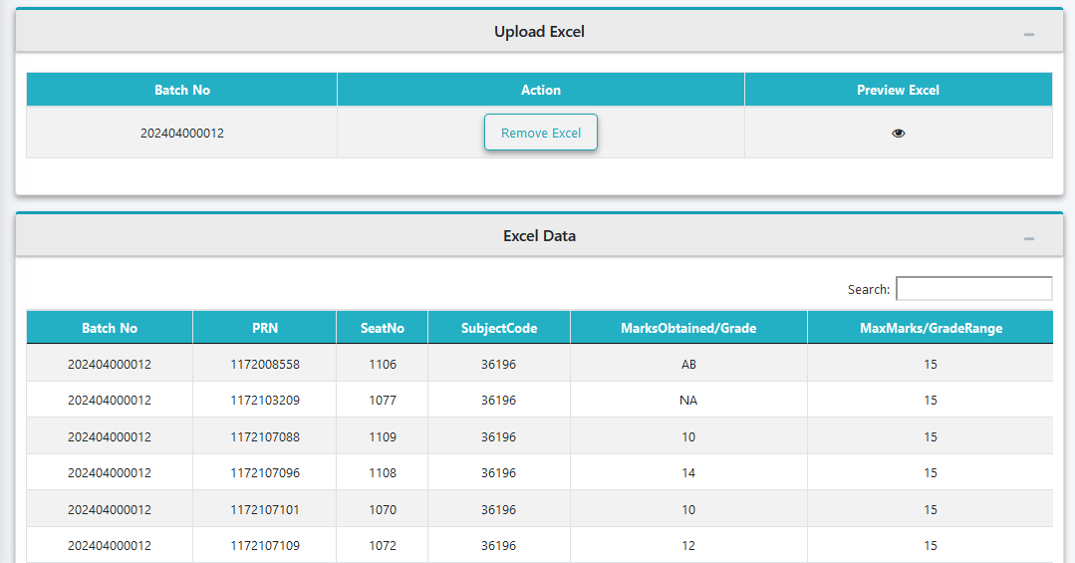
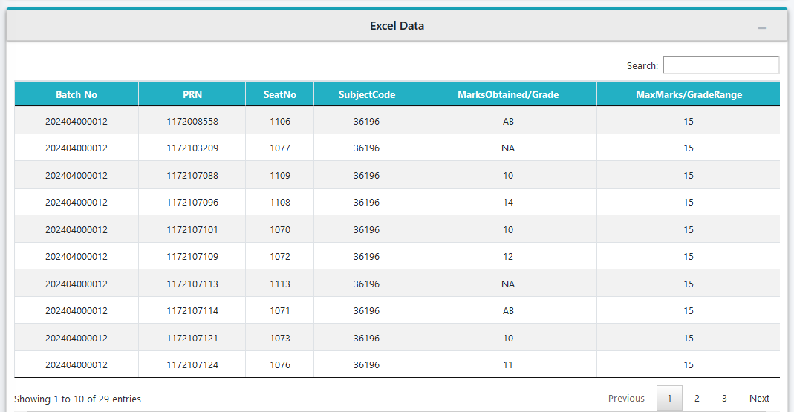
11. After that again click on Marks Entry Menu.
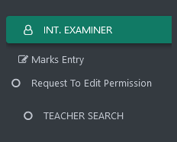
12. You can see the preview here also. (click on preview button.)

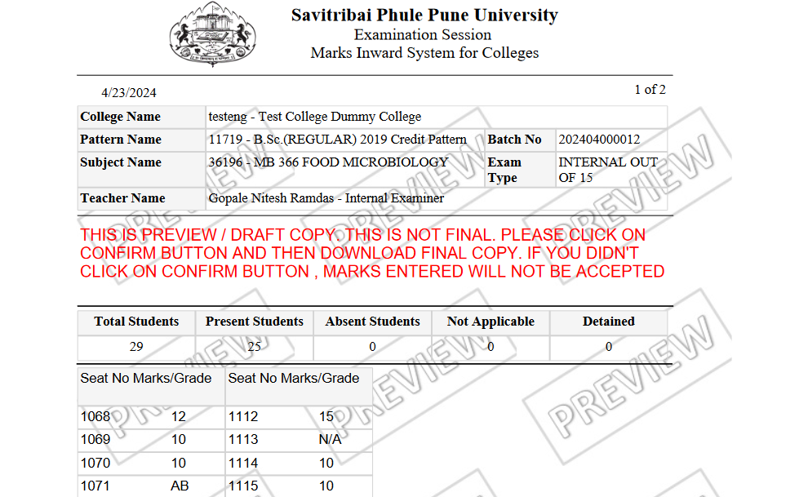
13. same old process for Batch confirmation Click on Confirm button. After shown following massage. (Do You Want To Confirm?Once You click on confirm button then marks cannot be changed.)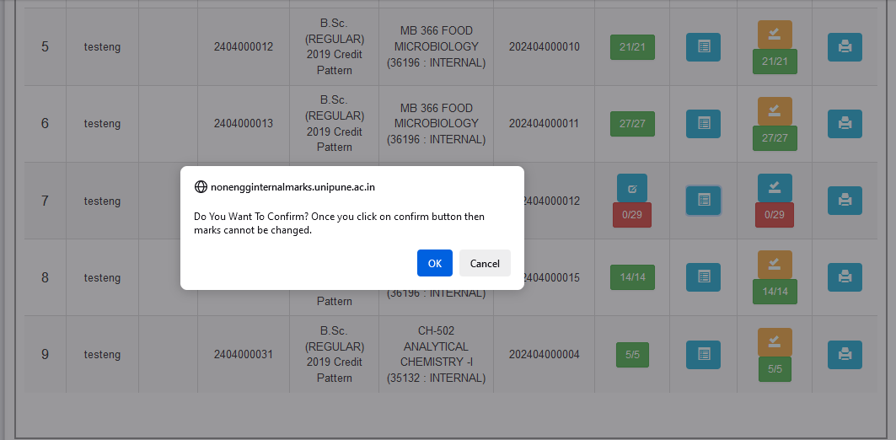
14. Before confirmation system need OTP witch will send on appointed examiner’s registered mobile no. for that click on Send OTP Button.
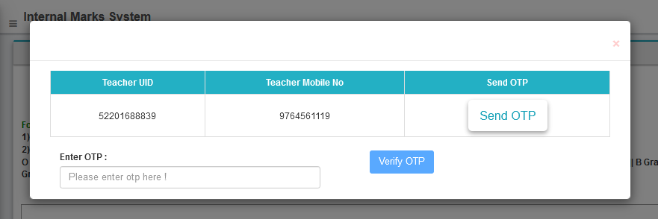

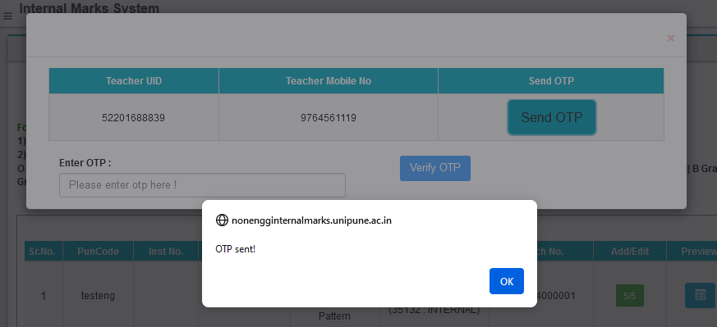
15. Enter OTP , Click on Verify OTP. 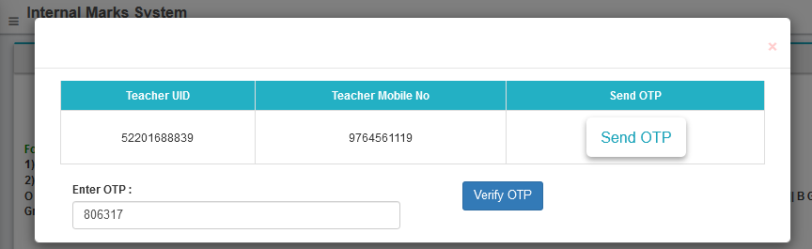
16. Shown Message as like follow.(Click on ok)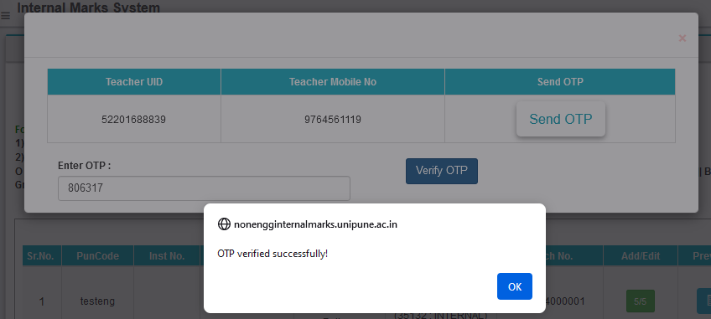
17. Shown following message.(Batch Confirm Sucessfully Please Click on Print Button to Download Report).
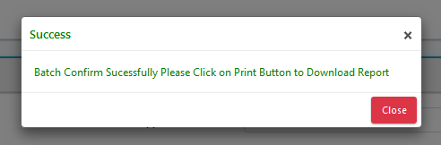
18. After Confirmation button colour will be change. Click on print button.

